Type Questions

5 T\F
5 MCQ
5 Fill in the blank
3 Short Answer
2 What is the output
Find the errors in the following code
Practical (writeing code)

Ch1
1-Choose
2-Common request methods:
GET , post
3- HTML used to structure document
4- web server …….
5 - Document representation using Hypertext Markup Language (HTML)

- What are the limitation of IP?
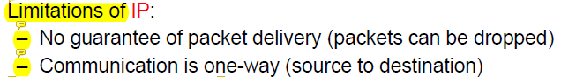

- Describe the structure of HTTP request and response?
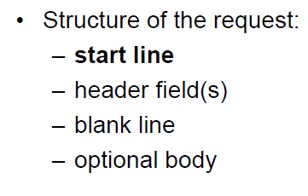
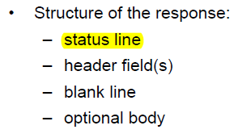
Ch2

1 Text put between the ________ tags appears in the browser’s title bar (i.e., the dark bar at the top of the browser window).
a) <h6></h6>
b) <title></title>
c) <h1></h1>
d) <head></head

2.6 In the statement <a href = "address">, href is a(n) ________ of the a element.
a) anchor
b) element
c) label
d) attribute
2.9 The location of an image is specified in the img element’s _______ attribute.
a) location
b) image
c) src
d) source

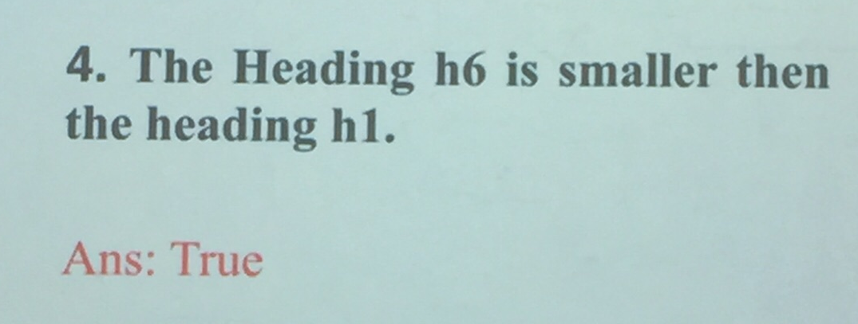

5. Which attribute is used with img tag to display the text if image could not load in browser?
a. description
b. name
c. alt
d. id

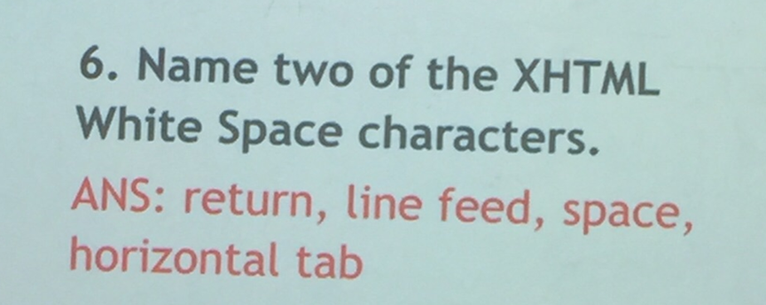

7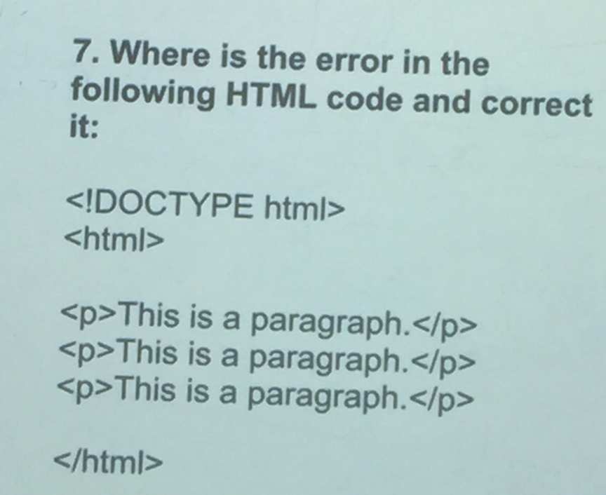
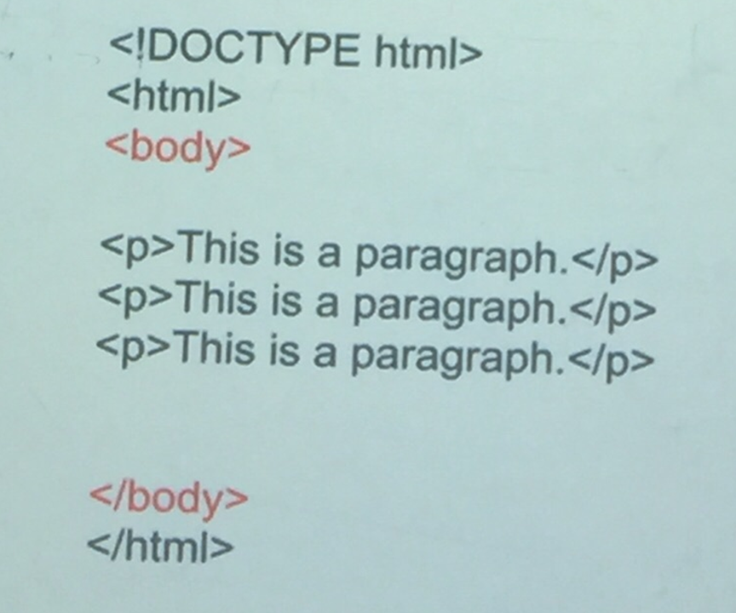

Ch3
- background-image property specifies an image to use as the background of an element.
- 12. External style sheets are saved with the ________ extension.
a) .html
b) .txt
c) .css
d) .txtcss

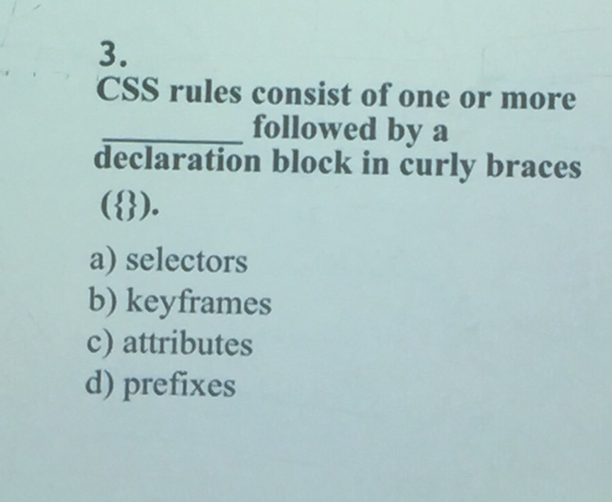
a)

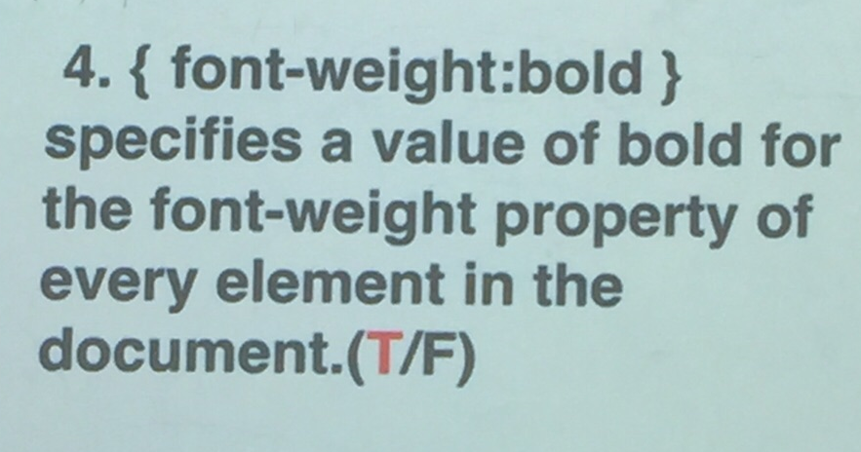

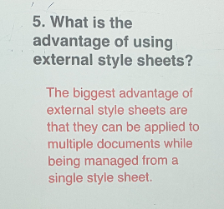
6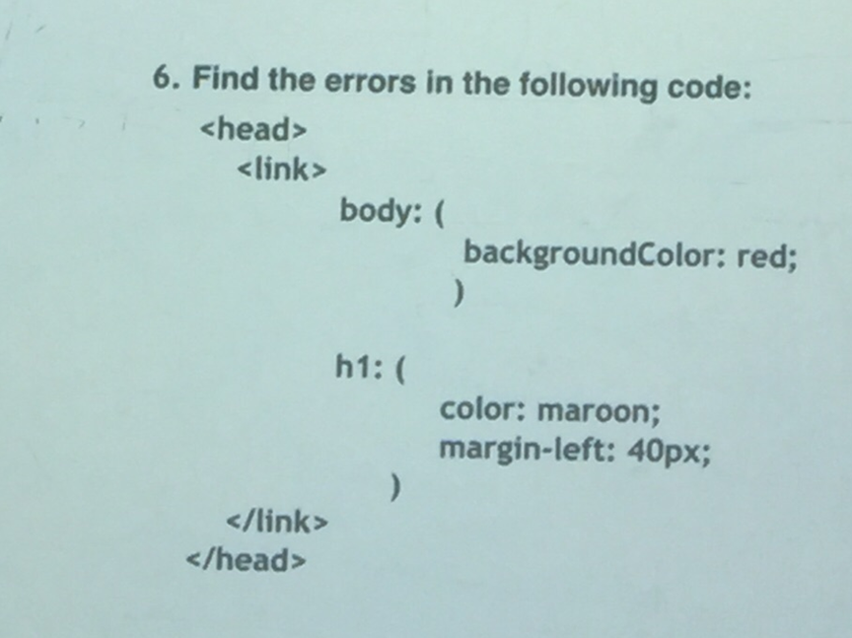

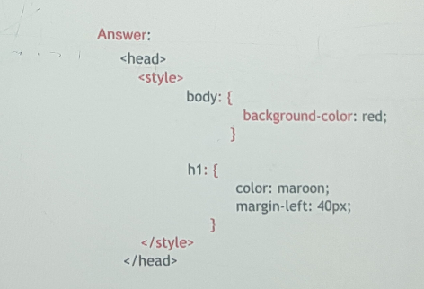

7/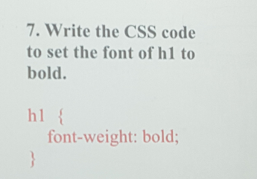

Ch4
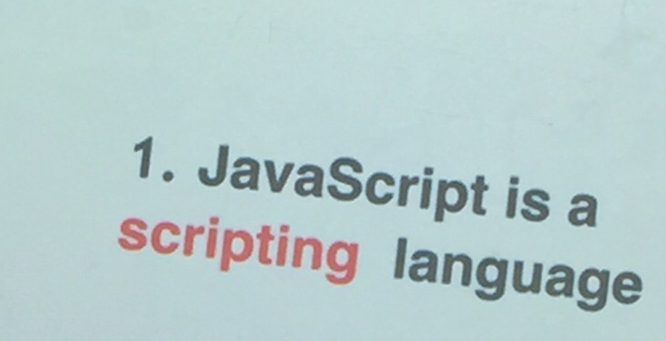

2/An alert dialog displaying the text "Welcome!" is created by calling _________.
a) window.alert( "Welcome!" );
b) alert.window( "Welcome!" );
c) window( "alert = \"Welcome!\"" );
d) window( "<alert> Welcome! </alert>" );

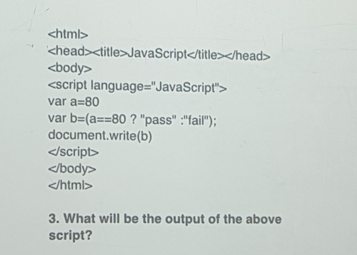
The answer: pass

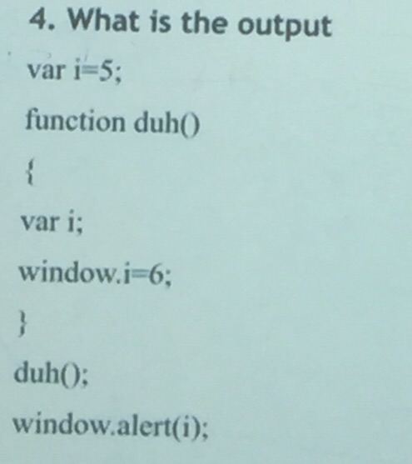
The answer:6

Ch 5

1 Event ________ fires whenever a mouse cursor moves into an element.
a) mousedrag
b) mouseover
c) mouseout
d) all of these

2/

